From “Nowhere to Somewhere”

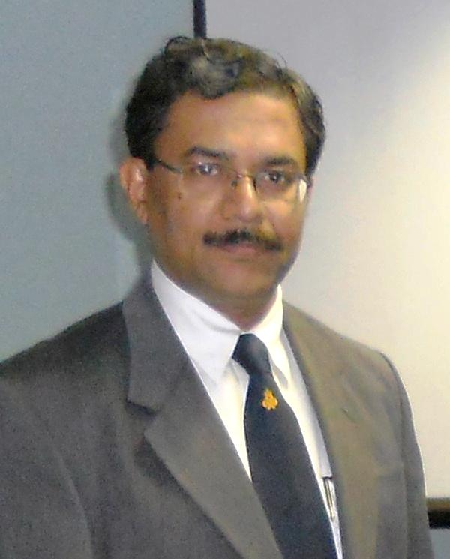

Prof. D. N. Singh
Dept. of Civil Engineering, IIT Bombay

Whenever there is a cyclone, the tallest of the trees get uprooted first; never do the small grass, one should always be like the small grass…. this philosophy was implanted in me by my parents, (Late) Sri Dharmendra N. Singh ji and (Late) Smt. Lakshmi R. Singh ji. Though I try following this philosophy in my day-to-day life, my research scholars, students and now even the INAE, feel that I am probably the ‘Giant Sequoia’ of my field and hence have asked me to pen down a few words, which could motivate my fellow Indians. This is the dichotomy which I am facing presently but still would like to share a bit of what I have learnt from my life till date, you may call it a journey from “nowhere to somewhere”.

In my early life, I was very well groomed by my mother, an educationist who always motivated me ‘to do something new’ and kept on doing so until she breathed her last in 2010. Also, I used to imitate my maternal uncle, Professor Ram Dayalji, Banaras Hindu University, B.H.U., a renowned plant pathologist. His laboratory at B.H.U. was my destined place whenever I would visit Varanasi during summer breaks. I remember using the ovens in his lab to prepare “pan cakes” and distributing it amongst his students and co-workers. This might have got imbibed in me to have later motivated me to develop my own laboratory and a research group at the Indian Institute of Technology Bombay (IIT Bombay).

Mentored by Professor Madhav, I joined Civil Engineering B.Tech. program at IIT Kanpur in 1982. I took up several jobs as a B. Tech graduate, soon to realize the redundancy of the work. The drudgery eventually led me to the doors of higher studies and Professor Yudhbir and Professor Basudhar introduced me to this amazing world of research, where my thinking knows no bounds, and I could develop an urge to explore the ‘remaining 99 percent of the Nature’ which is unknown. Interacting with such great gurus made me determined to reach somewhere, by choosing a path that appealed to my sense of productivity, the most. As a child, I dreamt to be sailing in the air as a pilot; the vision was always to scale the infinite, which I am still doing. I experience similar thrill each morning when I am served ‘breakfast of ideas’ by my research group; I believe I am riding all their ideas right up to the ninth cloud. These informal interactions help me and my research scholars to take up several challenging and trivial projects, and help us in ‘growing together’. This also reminds me of the education that I received at Colvin Taluqdar’s College, Lucknow. Incidentally, Mrs. Kaur, Principal, City Montessori School, Rajendra Nagar, Lucknow, was instrumental in inculcating in me, an unimaginable capacity to ‘concentrate on your work’ for several hours, without thinking of ‘what is happening elsewhere’. ‘

I have believed that the ‘new generation researchers’ are mature and hold a staunch individuality, which should be respected. It is an entirely different era, without the conventional inhibitions and tameness. We should only observe them, interact with them regularly and intensely, and create role models; alternative to the hyped media-clad glamour achievers, reeling in the young minds due to the social media. Internet has brought everything at their finger-tips, which has its own pros and cons. There appears to be an exponential decrease in the tendency to figure out things on their own in the generation of ‘smart phones’ with the ‘less smart researchers’. Any scientific technological advancement could be a boon or a bane very subjectively, depending on the amount of judiciousness shown by the user. I frequently question my students, ‘Don’t you always choose to email your professor instead of directly meeting him/her?’ The fading bond between a teacher and students is one of my major concerns, for which I consider both the sides as equally responsible. It reminds me of my Ph.D. days, when I would generally start discussion with my supervisor close to the dinner/lunch time, at his apartment, fully aware of the fact that “food will be served very soon!” by his mathematician wife. Having played both the student and teacher, I hold a strong opinion that such a bond fetches remarkable benefits to both the parties. As a student, I enjoyed the companionship of my teachers, and the chemistry, I feel, has social benefit only as a by-product. The major product of the irreversible reaction is the magnitude of achievements. Professor Chandra S. Desai, USA, motivated me to hold the international conference of the IACMAG, the International Association for Computer Methods and Advances in Geomechanics, at Goa during 2008. This turned out to be a huge success. I came to the international front for the first time, due to this event; I am so glad that I did it. Delegates from about 70 countries participated, as a big and the most memorable event in their lives. Professor Shamsher Prakash, is another name in the list of the influential people in my life. I won 2003 SP Research award instituted by Shamsher Prakash Foundation, MO, USA. A few years later when he visited my laboratory, he was impressed and satisfied that the award fell in the right hands. Professor Sukhatme, former director, IIT Bombay also has a very special place in my mind and heart. Without his help and support, I could have never been able to venture in the Geotechnics of atomic waste disposal, a multi-disciplinary topic dealing with a substantial amount of nuclear-chemistry. This interaction brought me close to the officials at Atomic Energy Regulatory Board (AERB), Bhabha Atomic Research Centre (BARC), Indira Gandhi Centre for Atomic Research (IGCAR) and Board of Research in Nuclear Science (BRNS). The issues discussed by these officials were cardinal in making me realize that the concepts of “Classical Geotechnology” will not be the panacea for addressing their objectives. I feel that this was the time when I started realizing, subconsciously, the importance of laying down the foundations of the theme “Environmental Geomechanics“. However, in an era when even the conventional subject was not much appreciated, convincing my students and colleagues about the ideology of this new theme was impeded due to the dogmatic platitudes such as ‘it is all about mixing soils with chemicals!’, ‘we are civil engineers hence why to learn science?’, ‘it lacks mathematics!’ etc. which prevailed for a long time. It was due to persistent efforts of my research group that we were able to start things from the scratch and evolve this new concept in an otherwise mundane subject. Needless to say, I am thankful to my critics (both in the academia and industry), who maintained faith in my philosophies and some ‘excellent’ outcomes could be achieved. It proved once again that constraints give birth to creativity.

‘Take decisions quickly, your opinion is my opinion’, I always advice my research group, which is my extended family and without whom I would have been nowhere. I have always believed that ‘in the academic profession, scholars become a part of your family’. This also helps me in establishing a bond of mutual faith that leads to understanding and respect for each other. I have always felt that I would have been nowhere without ‘the mentorship’ my students have provided to me, and I am extremely thankful to them for the challenges they posed to me, which has given me a lead in my research. I have been fortunate enough to encounter wonderful students; frankly I am yet to come across a ‘bad’ student. I still remember the first class of Engineering Mechanics at IIT Bombay and the students prompting that I should be doing something new and not merely teaching. That was a great kick start to something innovative which looks like my Environmental Geotechnology Laboratory http://www.civil.iitb.ac.in/~dns/env.html today! Research cannot be done if one is very reclusive; one needs to cooperate. For me this laboratory is much beyond the four walls of a RCC structure. Unfortunately, some times the laboratories become more of showrooms ‘showcasing variety of instruments and their keepers’, wherein the human touch is missing; if someone happens to break an instrument while working, (s)he is almost certain to be given a harsh word or castigation. I would in fact love such a happening, because it shows that the work is going on! All of us are fundamentally humans and hence the requirements of a human behavior must be fulfilled first and then comes the profession.

I feel I am still a student, being paid for learning new things every day, and will strive hard to continue to be so throughout my life, curiosity has always driven me right from nowhere to somewhere and I am still exploring new frontiers of my subject by interacting with the renowned researchers from electrical, nano-electronics, chemical, metallurgical and bio-technology backgrounds. I am not ‘scared’ of learning from them simply because I believe that one cannot be an expert in every field. I feel my students are my best teachers. I try to catch ideas from the questions thrown at me by them in the classrooms. ‘Ideas multiply very soon’, still I find some researchers do not open up, it is important to accept that one cannot know 100 percent of everything. I feel that each and every one has taught me something new, for me everybody is a source of knowledge. I try not to antagonize anyone, because for me individuals are not so important, but the personalities are. I may not be meeting the same individual again but I will definitely come across a similar personality; one should be aggressive at his/her work, for achieving something, but not haughty.

My failures have been various personal constraints; I always wanted to go abroad for higher education, but had to stay back. I remember Dr. A. P. J. Abdul Kalam, the then Principal Scientific Advisor, Govt. of India, appreciating my completely Indian education, during a prolonged interaction with him; in a flight from Agartala to New Delhi. I still believe that had it happened, I would have been a different personality altogether; this is where one has to believe in destiny, take it as a blessing in disguise and turn it into a sequence of opportunities which one could conquer to the best of one’s abilities. Be sure that something better than the one you expected will come your way. If one truly deserves, things will happen to him/her, either sooner or later, one just needs to make oneself fit for that. I have never planned for anything in my life except for my ‘present’. God has been kind enough to guide me through the best of the paths. To be successful and satisfied in the long run, one must have absolute faith in something external to one’s self; it could be as lifeless as a stone to as debatable as God. You have to be religious, but there is no need to go to the temples; the way ‘rich people worship’. Indeed my religion largely lies in building lives of several research scholars for whom their faith rests in me, sitting in the temple of technology---IIT Bombay. It is difficult to estimate how much this institute has given to me, and if I could give back even a fraction, I would be privileged. If IIT Kanpur was my “Janma Bhoomi”, IIT Bombay became my “Karma Bhoomi”. I feel that the extent and rigor of industry interaction, and the challenges associated within the ‘soil-rock-sea-waste’ interaction, which Mumbai provides, is of its own class. Needless to say, I learnt a lot from this city and I owe a lot to it.
I have learnt from my early part of the career that one can sustain even in hostile environment as long as the person has self-belief. While working in a group, it can be an arduous task to avoid conflicts. Such conflicts are inevitable considering psychologically every ‘personality’ is unique. But, ‘Swantah Sukhaya’ is one principle that guides me through. One should give an ear to every surrounding advice but do what pleases the ‘Self’; since both the physical and mental appetites are diverse for different personalities.

Today, several industries are utilizing outcome of my research, which never was in the realm of the classical Geotechnical Engineering, say about 10 years back. This has broken the common myth that ‘academicians and researchers have isolated themselves from the societal needs and live in their own world’. In my opinion consulting is very important; unless you learn from the field problems, what will you teach in the class? And if you do not teach contemporary things, intelligent minds will not receive them. This also helps in generating the resources, which could help in developing and maintaining day-to-day requirements of ‘conducting research and exploring novel ideas’. I could guide several Ph.D. theses, as I always had industry sponsorship. Industry interaction gives platform both to ‘apply your knowledge’ and ‘generate resources’. This way one can do the research which could help the society and it is mainly such research that is the need of the hour and would open up further avenues for exploration.

Several colleagues have asked me; ‘how do you manage a large research group’? It is fairly simple to manage them since I do not have to! I am one of them and we all manage each other. I make it a point that everyone is satisfied with me and hence I enjoy full support whenever I need. This is the sole reason why ‘otherwise silent worker like me’ could manage to bring more than 105 editorial board members, when he launched an international journal Environmental Geotechnics, ICE (Institution of Civil Engineers) Publishing, London, UK, (www.editorialmanager.com/envgeo). The best researchers from all over the world joined this endeavor easily and happily.

I try to remain ‘self-motivated’ and ‘compare with myself’, I have never ending expectations from myself and I try to gratify them through hard work and absolute dedication. What keeps me on my toes is that India requires a lot of good human beings and professionals, and I am constantly working towards shaping future, and career, of my students. This country is known due to its ‘individuals’ and not due to ‘the system’; if we want to make any change, it has to be an ‘individual effort’.

I am grateful to God that both my ‘family’ and the ‘extended family’ are satisfied with me, I have stirred them together in appropriate proportions such that I get adequate flavors of both in my life. My sister, Dr. Neena reminds me of my favorite game during my early child hood that was making a small weighing balance out of the empty cans of cherry blossom shoe polish. I have always believed that family support stabilizes you in the worst of the situations, but you should not isolate them. Your family members should be completely aware of what you do; in fact I make them a part of what I am doing. We hold regular get-togethers at home or outside, Ritu, my wife, knows even favorite dishes of every student and Yashi, my daughter, cherishes these moments well. We wish them on their birthdays and accomplishments; we are all like a big family. I believe that with transparency in ones work, unnecessary misunderstandings can be avoided, which in turn fosters creative thinking and growth.

I would like to conclude with the adage ‘remain inquisitive throughout life and have a very different perspective towards nature where most of the things evolve’.

