From Physics to Engineering Physics

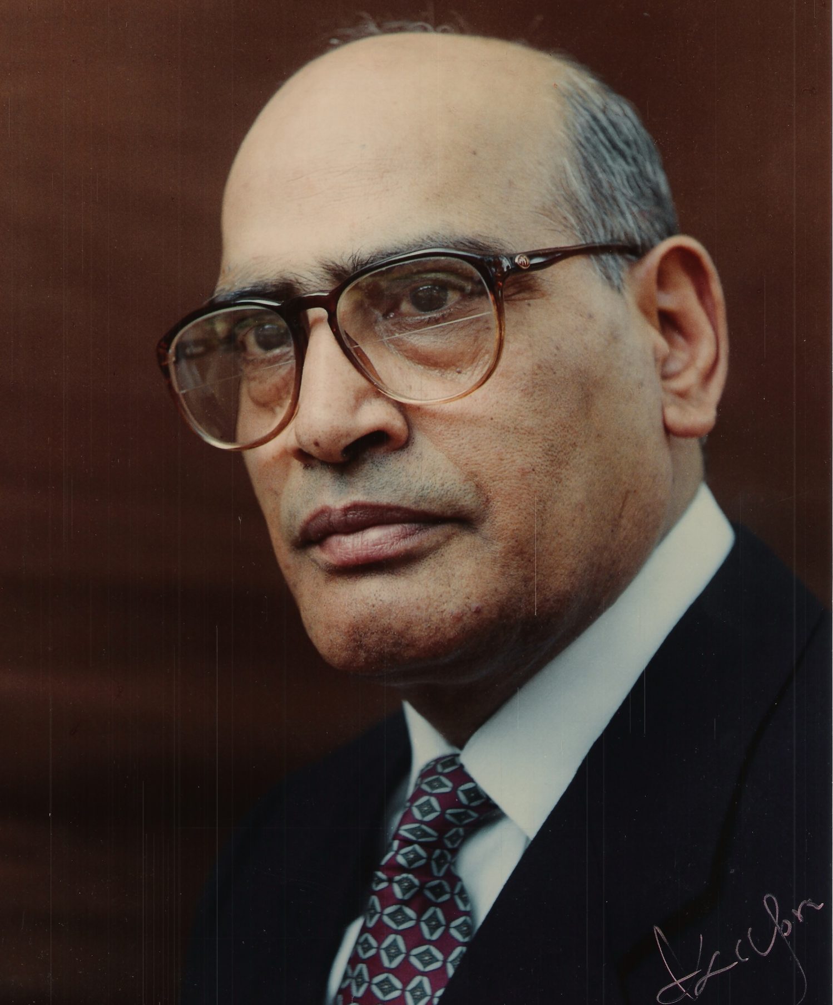

Professor K L Chopra
Former Director, IIT Kharagpur

I was born in a small village called Chahal Kalan in Pakistan. I used to walk about 3km to reach my high school situated in Qila Didar Singh. Our science teacher taught us general science in the 9th grade. He was very particular in demonstrating some simple science experiments to us as a part of our practical class after the school hours. I was a topper in the class and I missed one such session. The teacher was furious and told me that experiments are the soul of science and that I will never become a scientist unless I learn to do experiments. This harsh advice has impacted my future career as an experimental physicist so much so that I believe only what can be seen or verified in an experiment. After being promoted to the 10thclass, the tragedy of partition of India took place and our family, like millions of others, had to hide and save our lives from fanatic mobs by moving on foot with little belongings to nearby military supervised camps. After months of moving from one refugee camp to another, our family reached Delhi where I got admission in DAV school in tents for refugees where I topped the 10th grade examination. After completing my intermediate, I joined BSc (Hons) and thereafter MSc.in Physics programmes of Delhi University.

We were taught a lot of Physics in Delhi University by some of the best known professors of Physics at that time in the country. But, there was little excitement or inspiration since there was no attempt to relate the Physics taught to us to any thing around us which we could appreciate. For example, we were taught in great details the theory of dynamics of a spinning top but were never told its connection to a practical application of a gyroscope. Photons are massless and have energy but no momentum. When I asked how momentum arises and how we know it, I was told to find it out myself in the library. I found out that a very simple experiment of observing the rotation of a very light vane in vacuum on absorption of light on its blackened side demonstrated nicely the transfer of momentum by the photons. We were taught crystal structures of materials but we were not told as to why we need to have this information. Or, why Si and Ge having a diamond structure are important electronic semiconductors. Even more dull were the laboratory experiments which we were expected to perform but which had little to do with what Physics was being taught to us. Experiments such as measuring the viscosity of water, or the observation of Newton’s Rings did not stir any imagination or excitement.

I was selected for a World University Fellowship to pursue a PhD programme in Physics at the University of British Columbia, Canada. The selection committee for the Fellowship asked me what research I wanted to do. Having read a bit about the work in Columbia University on the measurement of the size of a nucleus, I spoke on the subject and told the committee that I wanted to be an experimental physicist. On reaching the University of British Columbia in Vancouver, Canada in September 1954, my would-be supervisor, Prof James Brown, told me that the quantum behavior of superfluid liquid helium below 1K would be an interesting PhD project. I was excited about studying the fluidic behavior of a zero viscosity quantum fluid which flows out of any container against gravity via a micron size thin film .However, I told my supervisor that , before starting my research, I would like to learn to work in the workshop with my own hands. I was taken to the departmental workshop as an apprentice. I learned to use machine tools, different lathes, soldering, welding, glass blowing, silvering of glass dewars, some electronic instrumentation , etc. As was the practice in those days, I built my own vacuum system out of glass ware , with a mercury diffusion pump. I prepared silvered glass dewars for liquid helium and liquid nitrogen . Low temperatures were measured by using a thin India ink dot written on a piece of paper as a temperature sensor. A simple Wheatstone Bridge circuit was used to control the low temperatures. An ultrasonic transducer was used to move liquid helium in narrow channels. Micron size channels for liquid helium flow were fabricated by first filling a thin Cu-Ni tube with bare copper wires and then by drawing down the tube through successively decreasing size of dies. Beautiful hexagonal shape channels so formed became the subject of my very first research paper. Working with a very competent and helpful technician to liquefy helium , and to recover evaporated helium gas , to purify it, and to test its purity before recycling it were experiences of sheer delight. Watching liquid helium flow out of a glass container against gravity, and studying transition from a streamline flow of liquid helium to a turbulent flow were not only scientifically significant experiments but were also a very stimulating experience.

After completing my PhD in 1957, I had two stints as a post doctoral fellow. One at the Royal Military College of Canada, and the second as Max Planck Fellow at the Fritz Haber Institute, Berlin. In both cases, I was expected to set up my new experimental facilities from scratch since no such commercial facilities were available at that time. My research at the two places involved studying ultrasonic absorption in superconductors, and determining any asymmetry in electron density distribution in hexagonal metals by studying X-ray diffraction at helium temperatures with a helium temperature diffractometer which I built.

An extraordinary development took place in my career during 1962. Some US scientists claimed that ultrathin ( nanometric size) oxide films sandwiched between two thin metal films exhibit nonlinear current-voltage behavior which means one could make very small size cheap active electronic devices. I was offered a senior scientist position by a US company committed primarily to develop a commercial thin-film based electron devices. The properties of films and the device so obtained were found by all investigators to be not very reproducible which led some persons to conclude ( perhaps jokingly!) that thin films are a fifth state of matter ( besides gas, liquid, solid and plasma) which we do not understand. We must remember that, at that point of time , the processes of deposition of thin films by evaporation and sputtering were rather primitive and there were no nanoscale analytical techniques to determine the chemical, metallurgical or physical structure of thin- film materials .Excitement in the promising future of this new research area led private industries to innovate and achieve considerable improvements in the control of thin film deposition processes . The emergence of a commercial electron microscope at that time also helped a lot in structural studies of thin films. As a result of the research efforts of many of us, it became clear that properties of thin films of any material depended on how the atomic species are created, how these are transported to a surface, and finally how the atomic species get together in their random walk process to create matter ab-initio. It was established that thin films are created by complex nucleation and growth processes which are primarily determined by the minimization of surface and volume energies of growing nuclei. Since these basic processes are determined by a large no of deposition parameters, reproducibility of the properties of thin films depended on how reproducible the parameters are. Further, these studies revealed how to tailor useful and exotic properties of thin film materials. This knowledge led to the growth of a large no of thin film technology industries globally which made it possible to use thin films in numerous applications ranging from micro and nano –electronics, magnetics, photonics, integrated optics, solar cells, hard and tribological coatings for surface engineering, optically selective coatings, quantum standards , etc. Today, thin films of appropriate materials are an important and integral part of any sophisticated opto-electronic device . Thin Film Technology is, of course, the mother of what what goes today by the name “Nanotechnology”

Being a major contributor to the insightful research on thin-films , I, only 33 year old, could not resist spending my next three years to write the very first Treatise on the subject called “ Thin Film Phenomena” . The book was a great success . Known as the Bible of the field, the book published in 1969 and translated into Russian and Japanese is still read widely all over the world. At this juncture, I received a very generous offer of Senior Professorship from IIT Delhi which I could hardly refuse. I joined IITD on Aug 23,1970. I was given two large empty rooms to develop a Thin Film Laboratory (TFL). Despite little money available for research, many enthusiastic young MTech and PhD students and I worked hard with our bare hands to create several thin film deposition facilities literally from scrap and scratch . TFL grew into a globally recognized institution where a unique ecosystem of R&D nurtured “individual thinking and collective working” . Both students and faculty worked together to conduct research as also to consult and transfer technologies to several industries in the country. Some ten such innovations were translated into industrial products. After completing their PhDs, a dozen of our students have set up their own industries. Several TFL alumni occupy senior executive positions in major global thin film solar cell companies .

Seamlessly wandering from different domains of Physics to Engineering Physics to explore new frontiers of both science and technology of Thin Films has , indeed, been an exhilarating and entrepreneurial experience for our students , faculty colleagues and myself .

